Thursday, 3 September 2026, postcard

Duck salad and The Lion King

Breakfast "at" our hotel turns out to be served on the 9th floor of its sister hotel the Indigo, a block and a half away. Only two choices were available—the Continental buffet (£19.50) and that plus ordering hot dishes from the menu (£21.50). We chose the former, still more than we wanted. The buffet included a good cheddar, a good Brie, some bleu that I didn't try, cheddar with chili peppers in it, and what looked like cranberry Wensleydale. Also cooked ham and excellent soft salami. The Viennoiseries were good but full-size. Real and vegan Greek yogurt, cut fruit, and bread that looked just like French baguettes, but were actually pretty heavy and dense. The view, on the other hand, was stunning. We decided to look for breakfast elsewhere from now on.
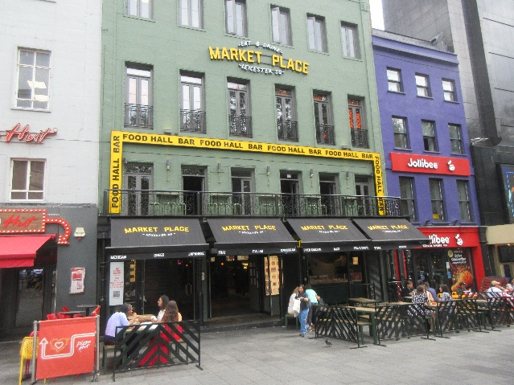
After a brief stop back at the hotel, we went for an exploratory walk around the neighborhood to soak up a little (well-filtered through cloud) sun for the jet lag.
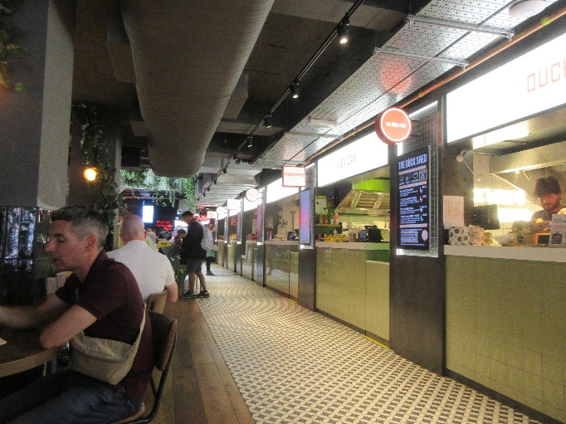
One great discovery, just steps from our hotel door, was Market Place, a stand-alone food court of 16 kinds of street food! I was particularly taken with The Duck Shed, which served roasted and pulled duck in three ethnic treatments (four, if you count vegan) as burgers, wraps, or salad bowls.
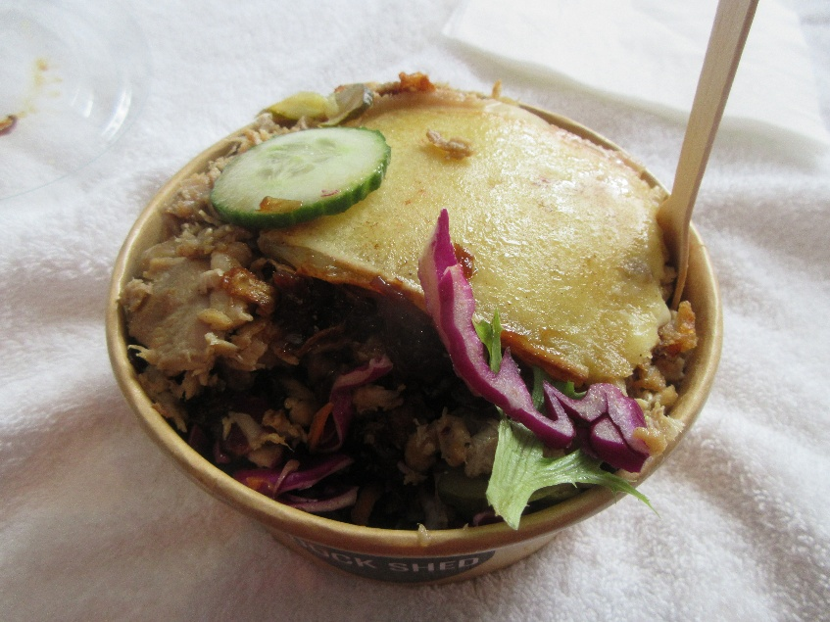
David spotted several promising pubs, where he hopes to get a pint (or three) of bitter during our stay. We read a lot of menus and chose Steak and Company on Irving St. for our evening's pretheater dinner. Back at the hotel, David wanted a nap and said he would skip lunch, so I worked on the computer for a while, then went out to The Duck Shed for a take-away French duck salad bow, which I brought back to the hotel. It was tightly packed into a cylindrical cardboard box, so it was a little hard to eat (with the little bamboo fork you can see sticking in it) without spilling bits everywhere, but it was outstandingly delicious! It included crispy salad greens and lightly pickled cucumber slices (which the menu described as "cornichons"), topped with lots of pulled duck, in turn topped with "onion chutney" (which seemed to have a lot of hoisin in it) and a slab of melted raclette cheese. Wow. David admitted later than he was waiting for me to vet the Duck Shed food before he went there for a pulled duck burger.

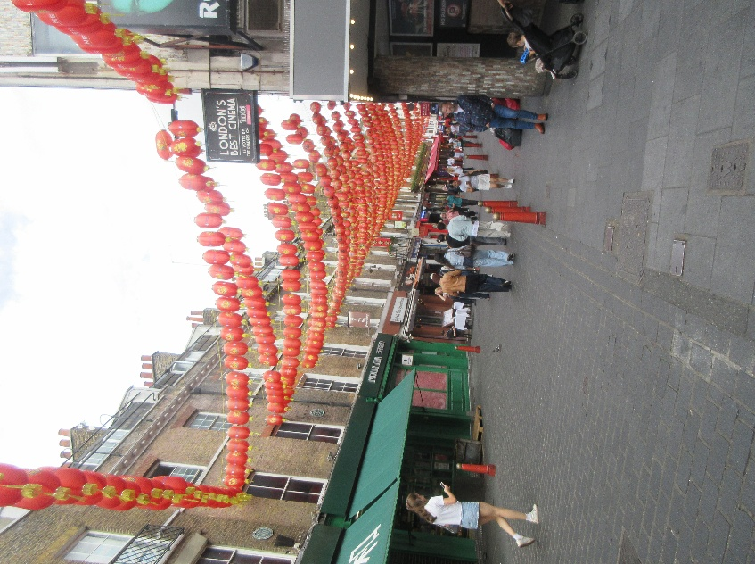
I then went on my own exploratory stroll, in the other direction, toward Chinatown, which is two or three streets wide and maybe 10 blocks long, and which you can actually see from our hotel's door.

It's easily recognizable, even in aerial views, by the strings of bright orange lanterns hanging above the streets. As I took this photo, our hotel was half a block to my right.

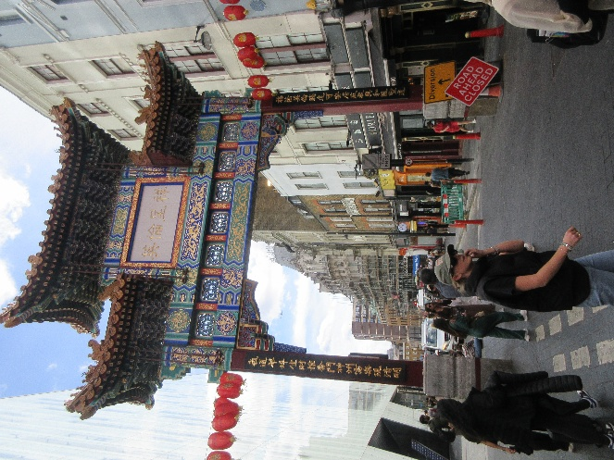
The Chinatown gate is a couple of blocks behind me.

In that half block between the hotel door and the first street of chinatown, I came across the door to Notre Dame of France, a lovely, round, Roman Catholic church.

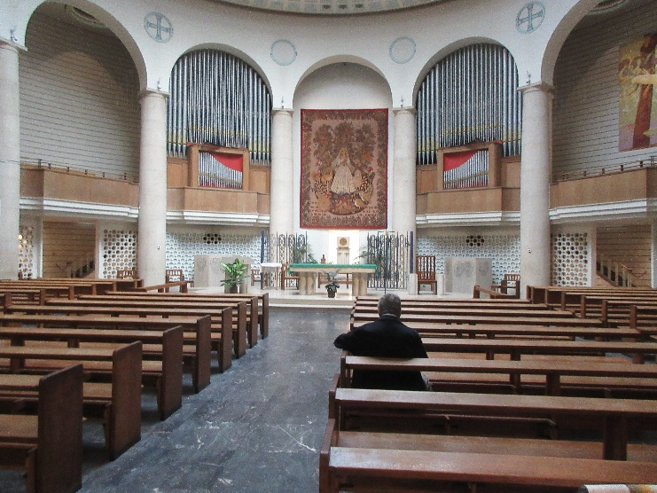

The streets of chinatown are lined with ethnic food stores and tempting restaurants, including one I spotted that serves nothing but dim sum all day every day. Alas, I doubt I'll be able to talk David into that. Or even into the buffet place next door.

One item that I was seriously tempted by was displayed in a bin on the sidewalk—coconuts for drinking coconut water.

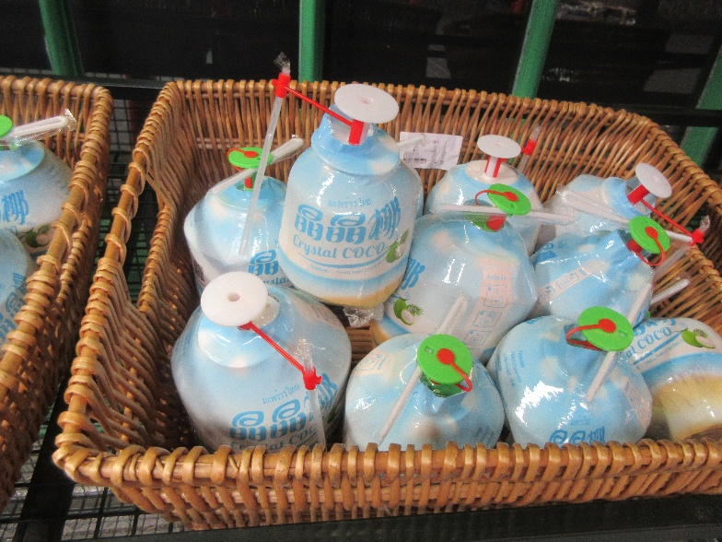
In both Brazil and China, we've come across stands selling them, but freshly cut before your eyes and handed to you with a straw. These were precut, fitted with stoppered drinking ports, and sanitarily shrink-wrapped, each with a sanitarily wrapped straw. I guess you pull off the flat stopper, stick the straw in and sip away. Afterward, if you want, you can crack the coconut to get at the meat inside. Fun!

Next, I strolled down to check out the National Portrait Gallery, just a long block off the other side of the square. I was able to verify that (a) it's free all the time, (b) it has portable folding stools (although they're the heavier metal kind), (c) the staff recommend that you take the express escalator to the top, where the oldest portraits are, and work your way down (and forward in time), (d) it has a café and two table-service restaurants, and (e) we could spend days in there.

I immediately spotted old friend Charles Darwin, and I really liked this photo of Queen Elizabeth II with two white draft horses.
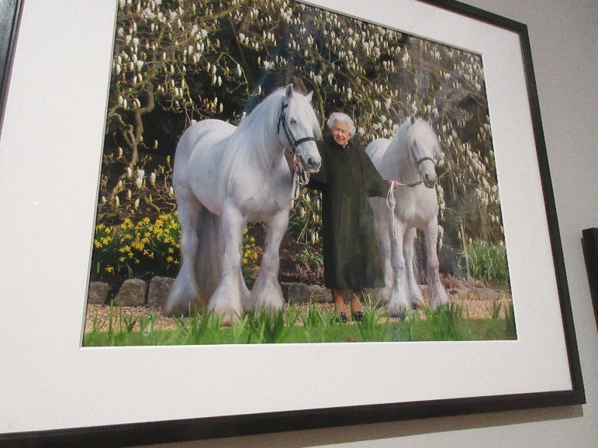
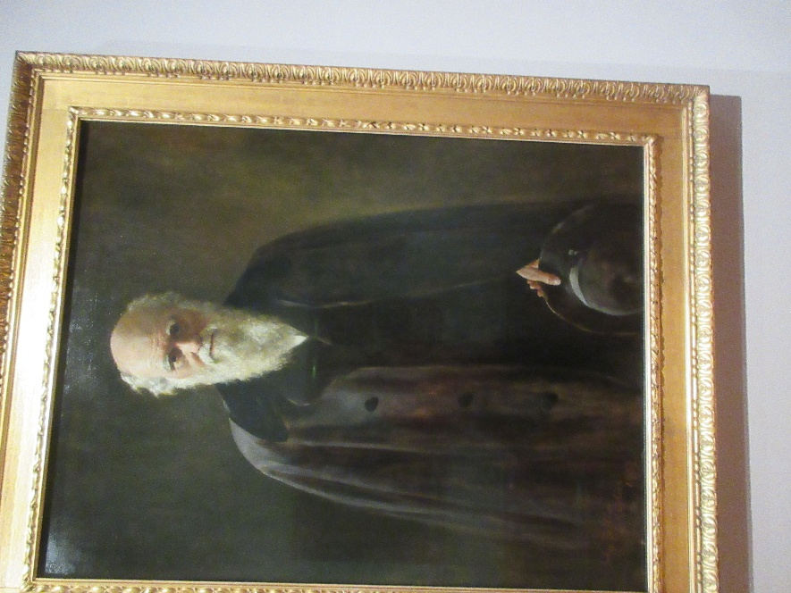

Back at the hotel, I caught up with David, and we strolled down to Steak and Company for dinner, cutting off about a third of our walk to the theater in the process. The restaurant's gimmick is that they bring you a very hot stone on a tray on which you cook your own steak. You start by choosing your cut (I chose 10-oz ribeye, and David chose 6-oz wagyu sirloin), then choose (from about four choices for each) your butter, your salt, and your sauce. You even have the option (which David took) to skip the stone and have the chef cook your steak. We ordered mashed potatoes to share.

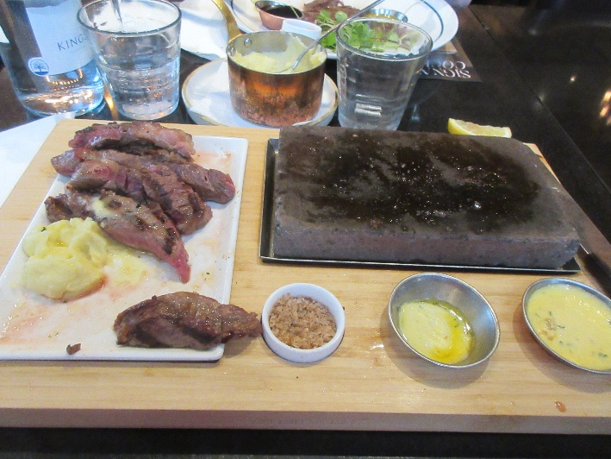
I was a little disappointed that what I got was not raw steak that I cooked myself but steak that had been grilled on one side only. I put some of my garlic-parsley butter on the stone and gave each piece only the quickest of sears on the raw side, because it was already pretty much the rare side of medium rare that I would have ordered from the kitchen.

The three little dishes hold my "steakhouse special" salt, mostly melted parsley garlic butter, and béarnaise sauce.

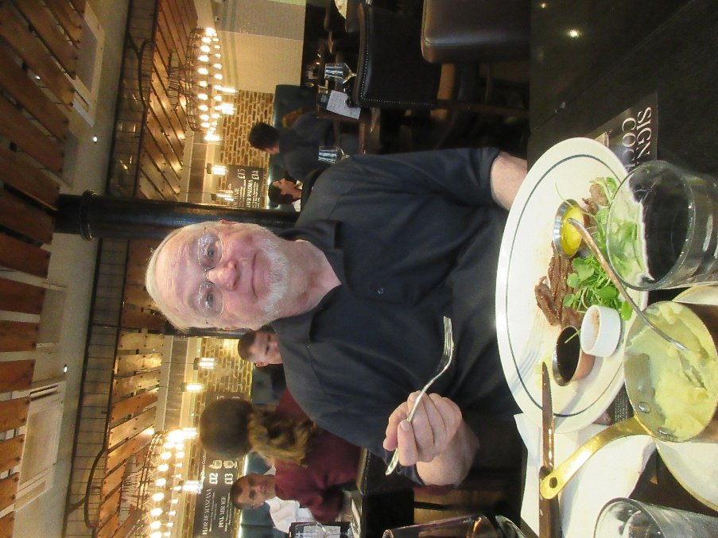
Once they had brought David a hot stone and he sent the whole thing back because he had specified the "plated" option, he was pretty happy with it. He got plain salt and excellent red wine deglazing sauce.

For dessert, we shared an order of "Eton mess," a crisp meringue shell topped with strawberry sorbet, whipped cream, strawberries, and raspberry coulis.

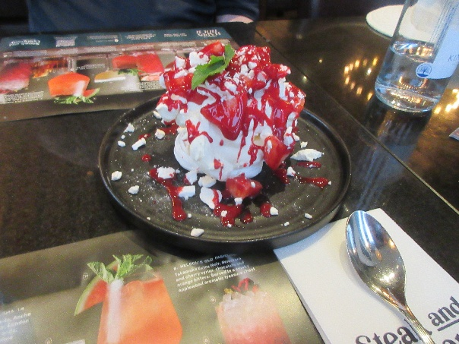

Then it was on to the Lyceum Theatre for The Lion King. Rather different from the production we saw in New York, but excellent none the less. Rafiki wasn't the singer that the one in New York had been, but she was an actual speaker of an African click language (probably Xhosa)! Her speeches were amazing to hear.

